Enterprise MLOps Architecture for Regulated Financial Systems
Brian P Bates

Table of Contents
Table of Contents 2
Executive Summary 4
A. Proposal Overview 4
A.1 Problem Summary 4
A.2 IT Solution 5
A.3 Implementation Plan 6
A.3a Justification of Plan 7
B. Review of Other Work and (B1) Works Informing Design 7
Review of Work 1 8
Work 1 Informing Design 8
Review of Work 2 8
Work 2 Informing Design 9
Review of Work 3 9
Work 3 Informing Design 10
Review of Work 4 10
Work 4 Informing Design 10
C. Project Rationale 11
D. Current Project Environment 12
E. Methodology 13
F. Project Goals, Objectives, and Deliverables 15
F1. Goals, Objectives, and Deliverables Table 15
F2. Goals, Objectives, and Deliverables Descriptions 16
G. Project Timeline with Milestones 20
H. Outcome 20
References 21
Appendix A 24
Appendix B 25
A. Summary 26
B. Review of Other Work and (B1) Works Informing Design 27
Review of Work 1 28
Work 1 Informing Design 28
Review of Work 2 28
Work 2 Informing Design 29
Review of Work 3 30
Work 3 Informing Design 30
C. Changes to the Project Environment 31
D. Methodology 32
E. Project Goals and Objectives 34
F. Project Timeline 37
F1. Goals, Objectives, and Deliverables Table 37
G. Unanticipated Scope Creep 39
H. Conclusion 40
I. Project Deliverables 41
References 44
Appendix A 45
Appendix B 46
Appendix C 47
Appendix D 48
Appendix E 49
Appendix F 50

Executive Summary
This series of two successive documents outlines a hybrid-cloud MLOps architecture case study designed for regulated enterprise environments. The core details have been modified to maintain anonymity. The architecture enables organizations to migrate machine learning workloads from on-premises HPC systems to scalable cloud infrastructure while maintaining strict data governance and security controls. The design integrates containerized workloads, experiment tracking, and pipeline orchestration to support repeatable, production-grade machine learning operations.

A. Proposal Overview

A.1 Problem Summary
Acme Banking Corporation is lagging behind industry peers in terms of artificial intelligence (AI) technology preparedness and adoption. A little over 10 years ago, the company invested in a data science department that reports to corporate information technology (IT). The investment included purchasing high-performance computing (HPC) workstations for each data scientist on the team. Initially, the impact of running statistical analysis on bank and industry data propelled the company into a better position for its mortgage products and corporate investment strategies. Appendix A shows the current HPC architecture.
Over the years, these data scientists have been overwhelmed by requests from various departments in the company, ranging from consumer behavior pattern recognition for branch managers and ATM deployment programs to commercial product lines relevant and competitive in the high-cost-of-living West Coast market. As a regional bank, Acme Banking Corporation isn’t as well established across the nation, and the newly appointed executive leadership team is looking for evidence of sustainable growth patterns for expanding locations.
These converging demands, in addition to the high cost of running HPC on-premises, keeping the data science team utilized, and a broader corporate initiative to ready the business for the future of AI, have provided the opportunity to migrate these statistical and machine learning (ML) workloads to cloud infrastructure. Additionally, the practice is not very resilient because the data science team is solely responsible for running ML workloads end-to-end. Recently, one of the principal scientists left the bank for another job opportunity with a big tech company, and with her, she took years of tribal knowledge. Migrating to the cloud will modernize the data science practice by implementing resilient production-grade development techniques and quality control.

A.2 IT Solution
Solving this problem using a cloud-first strategy introduces many new design and planning aspects. The solution will require migrating the ML workloads to cloud infrastructure and enabling more of the company's employees access to run the ML workloads that they need. The data science team will not be replaced or disbanded. Moreover, their responsibility will shift to managing, maintaining, and developing the machine learning models for these projects. The enterprise architecture will also be a hybrid-cloud design because many of the core ERP applications and databases remain on-premises in bank-owned and co-location data centers. The ERP cloud migration is planned for 2027 and will follow the HPC migration.
Machine learning models will be managed through several new technologies that enable containerization, registration, version control, and monitoring. These components are critical to transitioning into a management framework and preparing for AI's future. Machine learning operations, dubbed MLOps by the industry, provide a roadmap for implementing this management framework (Visengeriyeva et al., 2024).
Using cloud-native MLOps technologies ZenML and MLFlow, the hybrid architecture will enable the elastic computing capabilities of the cloud while maintaining the financial benefits of the existing on-premises data warehouse. ZenML is enterprise software-as-a-service that manages and coordinates the various aspects of MLOps. Amazon Web Services (AWS) will be the cloud services provider for the additional cloud computing requirements. AWS Direct Connect will serve as the resilient connection between on-premises databases and cloud services. Cloud services include hosting an MLFlow server, artifact storage in S3, and AWS SageMaker, which will orchestrate machine learning steps through the pipeline. Finally, Docker will be a containerization solution for models and a versioning registry through their cloud-hosted repository, Docker Hub.
The combination of these technologies, as illustrated in Appendix B, will serve as the modernized machine learning infrastructure and the basis for MLOps. Acme Banking Corporation will become well-positioned to capitalize on future AI trends and use cases in conjunction with the data science team, which will provide expert oversight and corporate-sponsored training to employees needing access to advanced ML capabilities.

A.3 Implementation Plan
Using an agile project management method described in section E, the implementation will begin with a comprehensive responsibility matrix to define who is responsible for which component. Implementing this solution will have multiple integrated systems and involve most of the bank’s IT, cybersecurity, and data science teams. Vendor personnel will participate in the new infrastructure deployments for new enterprise components, such as ZenML, AWS, and MLFlow. The corporate IT and cybersecurity teams will assist in ensuring the connections are secure and robust for the direct connection between on-premises databases and the AWS virtual private cloud (VPC). An existing Microsoft Active Directory will be used for authentication and authorization across the new architecture. The IT team will manage these integrations with consultation from the data scientist for what roles are necessary.
Integrating ZenML, MLFlow, and AWS SageMaker will be the responsibility of the data science team, along with vendor support. Using an iterative approach and running in sprints, functional integrations and features will be delivered every two weeks until project completion. A completed project will finish with a series of tests performed by the data science team to ensure the accuracy of the migrated models.
Entering a maintenance phase, bank employees who are approved for access to the new machine learning capabilities will undergo formal training provided by the bank. The data science team will move into a supervisory capacity, providing expert consultation for employees, monitoring the systems, and developing new models through structured experimentation.

A.3a Justification of Plan
This implementation plan is appropriate because of the advanced nature of the project. Unforeseen challenges will likely arise, even when using reference architectures from vendors and industry case studies. This project is not a single product implementation but a combination of capabilities resulting in a complex system and, therefore, requires the iterative nature of agile project management paired with clear accountability. As this project is intended to prepare for future technologies, an emphasis is placed on function abstraction, which allows parts of the system to be replaced without requiring an entirely new system. Each function’s current vendor will likely have competitors in the future, giving the bank commercial options to avoid vendor lock-in (Singla, 2024).

B. Review of Other Work and (B1) Works Informing Design

Review of Work 1
Blackman and Sipes (2022) discuss the risks involved with democratizing machine learning capabilities and empowering citizen data scientists. With AI requiring many technical underpinnings provided by machine learning technologies, it is critical to ensure Acme provides ethical practices and comprehensive training before, during, and after the migration. A company that is enabled with technology and without the proper resources can make poor decisions much faster, putting its corporate reputation at risk. The authors suggest open visibility into similar use cases within the organization and ongoing education. Expertise will be fundamental to providing guidance and a final review of future projects before they are put into production.

Work 1 Informing Design
In reviewing these risks, it became clear that a cloud migration for the data science team would not eliminate their necessity in the expected ways. Conversely, the existing data science team will be pivotal in scaling the organizational machine learning capabilities across the various employee competency levels. The proposed solution for Acme Banking Corporation will require just as much subject matter expertise in operationalizing the MLOps framework from an organizational perspective as it will in implementing the core technical systems.

Review of Work 2
In the article “Top 5 Practical MLOps Use Cases”, the author describes how modern approaches to data science in organizations require integrating data science with operational practices to ensure the effective deployment and maintenance of machine learning models in production. MLOps is an acronym for machine learning operations, and the tools used are similar to those used in DevOps practices. At the center is architecture for scalability and resource management to ensure speed to scale and budget consciousness during lulls. Other tools necessary to deploy machine learning in production include continuous integration/continuous deployment, lifecycle management and iteration, collaboration tools, and monitoring for the ML model, where performance and experiments are tracked (Nguyen, 2023).

Work 2 Informing Design
In designing the proposed solution, this article served as a baseline for the MLOps tooling considerations. By reviewing practical examples of using MLOps, it was easier to bridge the theory of some more complex functions like model lifecycle management. For example, lifecycle management is a core problem with the current data science processes because the individual data scientist is responsible for their models end-to-end, resulting in a reliance on tribal knowledge. Model lifecycle management tools will solve this issue.

Review of Work 3
Fifteen years ago, there was an excellent cost argument for the capital expenditure to acquire hardware; however, with the modern economies of scale offered by cloud service providers, cloud computing provides scalable resources and services that have revolutionized data storage, processing, and analysis. Peter Wang writes in the article “How the Cloud is Changing Data Science” about how these platforms provide on-demand access to exceptional, leading-edge computational resources, enabling data scientists to efficiently handle large datasets and complex models without the constraint of traditional on-premises infrastructure. The author continues to discuss how advanced tools for managing frameworks, applications, and analytics are readily available, with simple integrations supporting the scalability and flexibility of any organization. Finally, with a cloud solution, collaboration and accessibility are seamlessly available for global operations, allowing teams to function well while geographically dispersed (Wang, 2023).

Work 3 Informing Design
For many years, Acme Banking Corporation has relied on on-premises technology and hardware ownership for high-performance computing. However, given the bank’s geographically distributed workforce and challenges with economically scaling workloads, the argument for capital expenditure has become more difficult. This article provided practical insight into how other data science organizations utilize elastic computing technologies in cloud and hybrid architecture, which had a material impact on the design of a hybrid cloud architecture for Acme Banking Corporation’s solution.

Review of Work 4
“6 Steps to Migrating Your Machine Learning Project to the Cloud” is a technical case study describing the steps necessary to replicate and scale machine learning capabilities using cloud computing. However, it doesn’t simply describe a lift-and-shift migration method. The author goes into detail by abstracting the technology layers specifically to optimize performance when using cloud services. Examples are provided for parallel processing using Amazon SageMaker’s API, the proposed machine-learning orchestrator for this project. Also detailed are methods for monitoring training experiments and analyzing runtime performance, both of which will be necessary for documenting the outcomes of the project and continued maintenance operations (Rand, 2021).

Work 4 Informing Design
This deep dive into the programmatic layers of machine learning was foundational in the overall system design process. Because the proposed solution is not a single product delivered by a vendor, a systems approach was necessary to design the multiple integrations properly. In describing each step required for machine learning using cloud computing technologies, Rand offers valuable insight into the methods that can be used for monitoring and optimizing runtimes and workloads.

C. Project Rationale
The AI boom is just beginning, with many companies undergoing significant changes in marketplace traction, corporate guidance, and strategic opportunities. These changes can propel or hinder organizations, as seen in many historical technology boom and bust cycles. This proposal seeks to invest in a resilient foundation of technical capabilities used today that is also ready for whatever AI-type use case requirements arise in the future. This is not an unproven AI tool but an infrastructure and framework to create resiliency and support for incremental AI adoption in the long term. Acme Banking Corporation and its stakeholders will benefit from this project because this modernization plan is based on the company’s existing use cases and follows best practices established for over a decade (Scully et al., 2015).
With the aging HPC infrastructure used by the Acme Banking Corporation’s data science team, the company is restricted from adopting modern machine learning and AI technologies unless it chooses to modernize. Faced with a decision to either purchase end-to-end solutions from leading vendors or design a system migration plan, the bank decided to evaluate the risks first. Acme Banking Corporation has completed a risk analysis for sending its proprietary data to solution providers and did not accept the risk of transferring data outside of its chain of custody. With a mandate to modernize ML/AI capabilities and the restriction of transferring data to end-to-end solution providers, the proposed solution was found justified.
This project can be successfully completed because the charter is to abstract the existing machine learning and data science tasks into process-oriented frameworks. The proposed frameworks have been in production environments for many years and have a large global following to maintain open-source dependencies alongside enterprise agreements to meet the bank’s SLA requirements. In many ways, the project will simplify machine learning operations with the additional implementation of tools to complete the MLOps framework.

D. Current Project Environment
After reviewing and researching the technology trends for the financial services industry, Acme Banking Corporation’s executive leadership team has come to the conclusion that the bank is a laggard with respect to AI readiness. JPMorgan Chase now requires all entry-level associates to know Python and has had a Python training program for employees since 2018 (Murphy, 2018). This marks a massive shift in the computer science skills the leading banks now expect. But it also indicates the modern adoption of the citizen data scientist for AI readiness.
Part of the overall business strategy is to leverage the vast amount of corporate data housed in the enterprise databases and data warehouses. The CIO is tasked with a five-year goal to transition the bank’s IT and technology group from a cost center to a profit center. This rotation will require increasing the scalability of technologies in lieu of forecasted hiring constraints and skills gaps (Crist, 2024). Organizationally, the CEO and CIO have partnered to align technology, education, and retraining strategies to address this goal.
The proposed solution directly aligns with the strategic vision the CEO and CIO have for the bank by addressing several core technologies modernization tasks. First, using cloud infrastructure will enable the organization to scale rapidly while maintaining a cost-effective technology budget. In using a hybrid cloud architecture, existing on-premises services can be kept until the next budget cycle for refresh. Second, expanding machine learning using established frameworks, techniques, and software will harden the bank’s approach to preparing for the future by pivoting from individual specialists to monitored processes. Finally, the architecture is a solid foundation for future technology intents to evaluate the applicability of large language models to operationalize AI for corporate data.

E. Methodology
For this project, the agile project management method will be used for several reasons. The primary motivator is the highly integrated nature of the software project, which will require many iterations to ensure API validation, data resiliency, programmatic authentication, and model accuracy. Agile project management is similar to waterfall in that it is a sequential process but delivers completed parts of the projects during several iterations (Sliger, 2008). Core tenants of agile are defined in the Agile Manifesto, which emphasizes collaboration with individuals to deliver working software over following the original plan (Beck et al., 2001). Due to the high probability of failure with IT projects, and especially machine learning projects, it is mandatory to project success that responding to change takes precedence (Columbus, 2023).
The five phases of agile project management are concept, inception, iteration/construction, release, and maintenance. In its first phase, the overall concept for the project is defined along with its value to the company. A project manager with executive sponsorship establishes a charter and identifies the stakeholders involved. These are among the most critical steps in project management.
The inception phase includes assembling the team of individuals required to complete the projects, and details for each party’s deliverables are specified. During this phase, schedules are compiled for the various reporting structures that are required for the execution of the project deliverables. Milestones for the project are documented along with the initial anticipated list of backlog tasks or assignments.
Iteration or construction is a series of short cycles with specific, completed components that are testable. Sprints are executed in two-week increments, beginning with sprint planning meetings and backlog grooming. This highlights the expected output from the sprint and prioritizes the workloads across the responsible team members. Daily scrum meetings are held during the sprint to quickly identify bottlenecks, roadblocks, or support needs during the execution phase. Upon the closure of each sprint, a retrospective is held to reassess the performance of the team and the performance of the project and accelerate responsiveness to changes in deliverables.
The final two phases are release, where the end users are finally handed the completed project, and maintenance, where support for the project is continued for the lifetime of the components. In the release phase, the data science team will be broadly responsible for training new users as they onboard. During release, bugs or errors will likely occur, which will be captured through the newly established support portal for the system. System behavior will be monitored closely for accuracy and performance during the release and maintenance phases. In the maintenance phase, the vendor personnel who assisted during the integrations are released, and the implementation is considered completed.

F. Project Goals, Objectives, and Deliverables

F1. Goals, Objectives, and Deliverables Table
Goal | Supporting Objectives | Deliverables Enabling the Project Objectives
- Project Initialization | - Define Charter and Stakeholders | - Prepare project documentation
- Project Initialization | - Define Charter and Stakeholders | - Stakeholder briefing
- Project Initialization | - Project Inception | - Assemble team
- Project Initialization | - Project Inception | - Establish schedule
- Migrate HPC Workload to Cloud Infrastructure | - Prepare Cloud Environment | - Prepare AWS VPC
- Migrate HPC Workload to Cloud Infrastructure | - Prepare Cloud Environment | - Configure monitoring
- Migrate HPC Workload to Cloud Infrastructure | - Containerize ML Models | - Standardize template for models
- Migrate HPC Workload to Cloud Infrastructure | - Containerize ML Models | - Implement versioning schema
- Migrate HPC Workload to Cloud Infrastructure | - Containerize ML Models | - Create and upload Docker image
- Migrate HPC Workload to Cloud Infrastructure | - Implement Hybrid Cloud Access Controls | - Integrate ZenML with AD
- Migrate HPC Workload to Cloud Infrastructure | - Implement Hybrid Cloud Access Controls | - Integrate ZenML with AWS Sagemaker and MLFlow server
- Migrate HPC Workload to Cloud Infrastructure | - Implement Hybrid Cloud Access Controls | - Provision access to artifact and data stores in S3
- Migrate HPC Workload to Cloud Infrastructure | - Implement orchestration and management layers | - Provision enterprise deployment
- Migrate HPC Workload to Cloud Infrastructure | - Implement orchestration and management layers | - Integrate ZenML with AWS Sagemaker for orchestration
- Migrate HPC Workload to Cloud Infrastructure | - Implement orchestration and management layers | - Integrate MLFlow for Model tracking and model registries.
- Quality Assurance and Hand-over | - Testing and Quality Assurance | - Data connection validation
- Quality Assurance and Hand-over | - Testing and Quality Assurance | - Data replication testing and validation
- Quality Assurance and Hand-over | - Testing and Quality Assurance | - Data lifetime testing
- Quality Assurance and Hand-over | - Testing and Quality Assurance | - Model regression testing
- Quality Assurance and Hand-over | - Training | - Training materials prepared
- Quality Assurance and Hand-over | - Training | - Hands-on training
- Quality Assurance and Hand-over | - Training | - Support portal updated
- Quality Assurance and Hand-over | - Workstation Decommissioning | - Clean memory and hard drives
- Quality Assurance and Hand-over | - Workstation Decommissioning | - Destroy hardware

F2. Goals, Objectives, and Deliverables Descriptions
Goal 1: During project initialization, project planning, documentation, and communication are defined and prepared. The documentation will be a series of living documents used to plan, track, and provide a historical record of why decisions were made during the execution phases.
Objective 1.a: The very first step in a project is to establish a charter and identify stakeholders. This will serve as the north star for the project and all activities required for the project.
Deliverable 1.a.i: Initial drafts and templates for project management will be prepared with the RACI (responsible, accountable, consulted, informed) matrix identifying who is responsible for each component.
Deliverable 1.a.ii: A stakeholder briefing will be held with the executive sponsor present, demonstrating executive sign-off on the plan and expectations.
Objective 1.b: Project inception includes the initialization of project resources and marks the official start of the project.
Deliverable 1.b.i: The project team is assembled and is comprised of employees, contractors, and vendor support personnel.
Deliverable 1.b.ii: A schedule is completed according to the personnel availability and maintenance windows, and the critical path is identified.
Goal 2: The primary goal of this project is to migrate all high-performance computing workloads off-premises and into cloud infrastructure. Several key applications and all of the databases will remain on-premises, and therefore, this project will require a hybrid-cloud architecture.
Objective 2.a: This project requires a new cloud environment to be provisioned using Amazon Web Services. While the bank has existing AWS accounts, proper billing reconciliation mandates all data science workloads be performed in a separate account.
Deliverable 2.a.i: A new virtual private cloud (VPC) will be provisioned according to AWS’s well-architected framework (Amazon Web Services, 2024).
Deliverable 2.a.ii: Monitoring for performance, security, and costs will be configured in several AWS services, including Cost Explorer and CloudWatch.
Objective 2.b: At the core of the project, containerizing machine learning models will abstract the models from the infrastructure and enable consistent control and monitoring.
Deliverable 2.b.i: Each of the individual machine learning models will be structured in a format that is consistent for versioning, updates, and annotations.
Deliverable 2.b.ii: A versioning schema for major releases, minor releases, and patches will be developed in a manner consistent with both best practices and the bank’s internal processes.
Deliverable 2.b.iii: Each model will be containerized into a Docker file and uploaded to DockerHub for control.
Objective 2.c: With a hybrid-cloud architecture, the on-premises Active Directory needs to be directly integrated into the various cloud services for the project.
Deliverable 2.c.i: ZenML, as the orchestration and management layer, will be integrated into the corporate AD for authentication and authorization services.
Deliverable 2.c.ii: ZenML will have authentication programmatically integrated with MLFlow and AWS Sagemaker to dispatch workloads.
Deliverable 2.c.iii: Both programmatic and user access will be provisioned for S3 depending on artifact and data storage for federated queries and workloads.
Objective 2.d: The orchestration and management layer will be commissioned.
Deliverable 2.d.i: Enterprise deployments of ZenML and MLFlow will be commissioned.
Deliverable 2.d.ii: ZenML management controls are integrated with AWS Sagemaker pipeline orchestration.
Deliverable 2.d.iii: MLFlow is configured for machine learning model tracking and registration services.
Goal 3: The second goal of the project is dedicated to quality assurance, addressing technology, people, and processes.
Objective 3.1: The testing and quality assurance objective seeks to validate the performance of the technical aspects of the project.
Deliverable 3.a.i: Connections from the on-premises data centers to AWS are validated resilient and secure.
Deliverable 3.a.ii: Data replication jobs writing data into S3 buckets are tested and validated for accuracy.
Deliverable 3.a.iii: S3 buckets used for data storage are validated for temporary storage using lifecycle policies.
Deliverable 3.a.iv: Models are run on known data with known results to perform regression testing on machine learning capabilities.
Objective 3.b: Training is a cornerstone to ensuring quality control from a people perspective. This objective is to ensure proper training and updated processes.
Deliverable 3.b.i: Written work instructions and training documents are prepared for the workforce. These documents will align new technologies and existing internal processes.
Deliverable 3.b.ii: Hands-on training with individuals and teams is held in both virtual and in-person sessions, depending on roles. Training will continue as the adoption of the new capabilities increases over time.
Deliverable 3.b.iii: The corporate support portal is updated with new information and reference material. Support contacts are added for the new software and infrastructure.
Objective 3.c: As a closing objective, all old and legacy equipment is decommissioned and destroyed to reduce future inaccuracies.
Deliverable 3.c.i: Old workstation memory and hard disks are wiped clean. Because these workstations were kept within the corporate network, they likely had proprietary information stored.
Deliverable 3.c.ii: Old hardware is destroyed or recycled with an emphasis placed on ensuring no data exfiltration is possible.

G. Project Timeline with Milestones
Milestone | Duration  (hours or days) | Projected Start Date | Anticipated End Date
AWS VPC prepared | 40 hours | March 1, 2025 | March 7, 2025
Models containerized | 120 hours | March 1, 2025 | March 21, 2025
ZenML implemented | 40 hours | March 8, 2025 | March 14, 2025
MLFlow implemented | 80 hours | March 8, 2025 | March 21, 2025
Data connection validated | 120 hours | March 1, 2025 | March 21, 2025
Regression Testing completed | 80 hours | March 21, 2025 | April 7, 2025
Roles updated in AD and rolled out to company | 20 hours | March 21, 2025 | March 24, 2025
Training Completed | 20 hours | March 24, 2025 | March 31, 2025
Workstation Decommissioning completed | 10 hours | April 1, 2025 | April 7, 2025

H. Outcome
While standard project management key performance indicators will be reported on to monitor management's success, three primary outcomes are expected from this project. The first is the operationalization of running data science workloads in a scalable and orchestrated way using the modern practices described by MLOps. This will provide a system and baseline for efficient use of cloud computing technologies, offering better utilization and investment metrics. It is expected that within one year of MLOps, the current machine learning use cases will provide a net return on investment. The base case for costs is established by the previous capitalized investment for HPC infrastructure and software. For the proposed solution, the costs will be measured by several sources, and due to the consumption-based pricing by the cloud service provider, the AWS Cost Explorer reporting tool will be used to summarize expenditures. Other software, such as the enterprise support license for ZenML, will be added to the ledger using annual contract costs.
Secondly, accuracy is vital for the bank’s evolution of machine learning use cases. Following the project’s completion, regression analysis will continue along with additional accuracy measurements (Mishra, 2018). This project will provide a standardized approach to running models and assessing the accuracy moving forward using classification accuracy. ZenML, as the core management layer, provides a function to run models as experiments using manual classification metrics as the base case. After the model runs, ZenML reports the accuracy compared to the base case as a ratio of correct predictions compared to the total number of input samples. The data is collected and benchmarked against past reports. Due to the high level of automation, a statistical variance will be tracked over time by ZenML’s monitoring functions to evaluate drift continuously.
Finally, the future of AI-enabled enterprises requires large language models and associated technologies to evaluate proprietary data owned by the bank. This project will validate a secure and temporary data replication method that allows production data to remain on-premises and only the data subject to analysis to be stored in AWS. The outcome will be consistent and accurate data replication with the redaction of personally identifiable information (PII) and other sensitive, nonrelevant data as screened by quality sampling through a federated query. The success of this outcome will be measured by the maintenance team running manual audits through federated queries to confirm the data in the S3 artifact store conforms to the lifecycle policy.

References
Amazon Web Services. (2024). AWS Well-Architected Framework. https://docs.aws.amazon.com/pdfs /wellarchitected/latest/framework/wellarchitected-framework.pdf

Beck, K., Beedle, M., van Bennekum, A., Cockburn, A., Cunningham, W., Fowler, M., Grenning, J., Highsmith, J., Hunt, A., Jeffries, R., Kern, J., Marick, B., Martin, R., Mellor, S., Schwaber, K., Sutherland, J., Thomas, D. (2001). Manifesto for Agile Software Development. https://agilemanifesto.org/

Blackman, R. & Sipes, T. (December 13, 2022). The Risks of Empowering “Citizen Data Scientists”. https://hbr.org/2022/12/the-risks-of-empowering-citizen-data-scientists

Crist, Carolyn. (August 7, 2024). Skill Gaps Can Cost Employers a Month of Productivity Each Year, Survey Suggests. https://www.hrdive.com/news/talent-data-skills-productivity

Mehreen, Kanwal. (October 8, 2024). Step-by-Step Guide to Deploying ML Models with Docker. https://www.kdnuggets.com/step-by-step-guide-to-deploying-ml-models-with-docker

Mishra, Aditya. (February 18, 2018). Metrics to Evaluate Your Machine Learning Algorithm. https://towardsdatascience.com/metrics-to-evaluate-your-machine-learning-algorithm-f10ba6e38234

MLFlow Project. (2024). Deployment. https://mlflow.org/docs/latest/deployment/index.html

Murphy, Ian. (October 10, 2018). JPMorgan Wants Its Financial Analysts to be Able to Code. https://www.enterprisetimes.co.uk/2018/10/10/jpmorgan-wants-its-financial-analysts-to-be-able-to-code/

Ng, Andrew. (April 20, 2022). Machine Learning Engineering for Production (MLOps). https://www.you tube.com/playlist?list=PLkDaE6sCZn6GMoA0wbpJLi3t34Gd8l0aK

Nguyen, Trinh. (September 12, 2023). Top 5 Practical MLOps Use Cases. https://www.neurond. com/blog/mlops-use-cases

Rand, Chaim. (November 28, 2021). 6 Steps to Migrating Your Machine Learning Project to the Cloud. https://towardsdatascience.com/6-steps-to-migrating-your-machine-learning-project-to-the-cloud-6d9b6e4f18e0

Scully D., Holt, G., Golovin, D., Davydov, E., Phillips, T., Ebner, D., Chaudhary, V., Young, M., Crespo, J., Dennison, D. (January 2015). Hidden Technical Debt in Machine Learning Systems. https://proceedings. neurips.cc/paper_files/paper/2015/file/86df7dcfd896fcaf2674f757a2463eba-Paper.pdf

Simon, Julien. (June 22, 2020). Deep Dive on TensorFlow Training with Amazon SageMaker and Amazon S3. https://julsimon.medium.com/deep-dive-on-tensorflow-training-with-amazon-sagemaker-and-amazon-s3-12038828075c

Singla, A., Sukharevsky, A., Yee, L., Chui, M., Hall, B. (May 30, 2024). The State of AI in Early 2024. https://www.mckinsey.com/capabilities /quantumblack/our-insights/the-state-of-ai

Sliger, M. (2008). Agile project management and the PMBOK® guide. https://www.pmi.org/learning/ library/agile-project-management-pmbok-waterfall-7042

Visengeriyeva, L., Kammer, A., Bär, I., Kniesz, A., Plöd, M.. (2024). Why You Might Want to Use Machine Learning. https://ml-ops.org/content /motivation

Wang, Peter. (November 2, 2023). How the Cloud Is Changing Data Science. https://hbr.org/2023 /11/how-the-cloud-is-changing-data-science

ZenML. (2024). System Architecture. https://docs.zenml.io/getting-started/system-architectures

Appendix A

Logical Diagram of Current Architecture
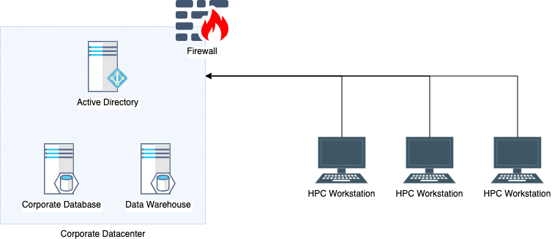

Appendix B

Logical Diagram of Proposed Solution

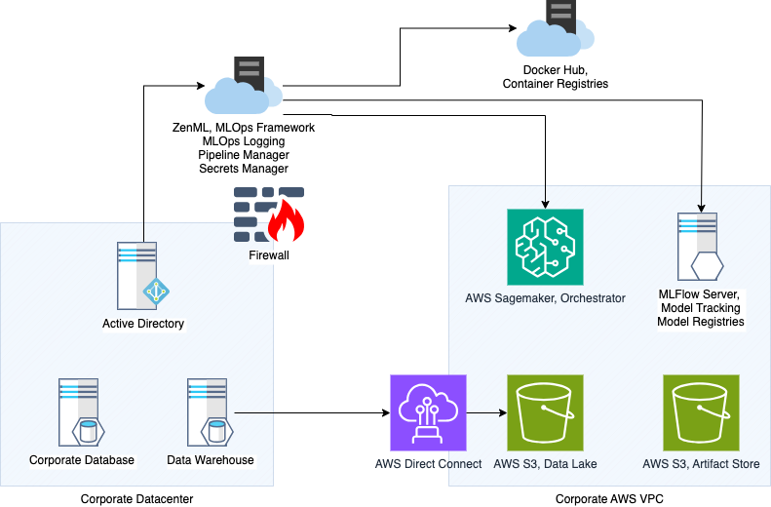

A. Summary
Migrating machine learning workloads from on-premises high-performance computing (HPC) workstations to cloud infrastructure managed by Machine Learning Operations (MLOps) frameworks is a transformative process increasingly adopted by organizations to enhance computational efficiency and scalability. As industries rely more on data-driven insights, the migration to cloud environments allows for greater flexibility, improved access to advanced technologies, and the ability to leverage powerful machine learning tools that are often too resource-intensive for traditional on-premises setups.
During an IT systems investment analysis, Acme Banking Corporation was faced with a decision to make regarding its data science program and the high-performance computing requirements for the practice. The evaluation demonstrated that the existing HPC workstation cluster needed to be replaced with new workstations or the workloads migrated to cloud infrastructure. The evaluation committee also found the company was lagging behind industry peers based on workforce access to modern machine learning capabilities and readiness for future AI use cases.
With executive sponsorship, the project team undertook a project with massive transformative potential with several key intentions. The first was to modernize the organization’s approach to data science, implementing a framework for development, management, and maintenance, ensuring a future-proof practice prepared for anticipated demand. The second intention was to implement a holistic system of scalable, on-demand computing services that any qualified employee can access in an effort to accelerate machine learning data analytics within the organization. Finally, in an attempt to address the increasing cost of hosting high-performance computing systems on-premises, the project team emphasized consumption-based cloud services to improve the return on investment for machine learning workloads.
Project execution experienced a bimodal distribution of timeliness for the objectives, with infrastructure tasks finishing faster than expected and model management tasks finishing slower than expected. The data science team tasked with the accountability for standardizing the version control and containerization of machine learning models fell behind schedule almost immediately due to internal discussions and disagreements over schema design. Already on the critical path, the data science team’s delay caused a cascading effect on the following phase, where they were responsible for quality assurance and training.
Despite the complications in structuring the migration of models from HPC to the new cloud infrastructure, regression testing proved very successful, and from the perspective of the executive sponsor, this was a much better outcome compared to inaccurate models delivered on time. Another welcome complication in a positive way was the engagement from the rank and file. Employees and lines of business managers alike began issuing requests for access to training and the system to perform their priority data analytics projects. This will be covered in more detail later in the report. However, this behavioral response was much better than anticipated and precisely opposite to what the executive team was expecting.
The project still struggles to officially close as completed. While the new MLOps framework is operational and the previous workloads have been successfully migrated, training and maintenance hand-over to IT support staff and the decommissioning of the HPC cluster remain incomplete. Due to the core responsibilities of the data science team, they have been the dependency for these objectives and remain over-utilized as the project nears completion. The executive team is actively engaged with the HR team to assist with temporary staffing; however, due to the influx of use case requests requiring restricted data, it’s unclear if temporary staffing will influence the timeline.

B. Review of Other Work and (B1) Works Informing Design

Review of Work 1
As costs and overall return on investment were among the top priorities influencing the investment committee’s decision, significant design and planning were spent on balancing a hybrid cloud architecture. Philip Hopkins (2024) discusses the benefits of optimizing AI/ML computing costs when taking a hybrid cloud approach with a focus on the storage layer. Hopkins (2024) argues cloud services should be used for the layers where elastic, on-demand consumption is required. For an organization with many petabytes of proprietary data that must remain stored but not frequently accessed, using a cloud service provider for the primary storage solution didn’t make sense from a cost perspective. He also describes how automation, or a management layer, is necessary to enable the dynamic scaling of resources as demand for cloud resources ebbs and flows.

Work 1 Informing Design
A hybrid approach made the most sense, especially since Acme Banking Corporation already had several production and standby database installations deployed on-premises. Abstracting the compute layer from the storage layer allowed the design of the solution to use a temporary Amazon S3 storage that would replicate the required data from the on-premises database. This S3 storage only hosts the data necessary for processing, and through a lifecycle automation policy, the S3 bucket purges after 30 days of inactivity. Based on the company’s 86 TB production database, this design has been calculated to save over $2,000 / month even if using Amazon S3 Intelligent Tiering (Amazon Web Services, 2024).

Review of Work 2
In the article “26 MLOps Tools for 2024”, Einat Orr, Ph.D., reviews the entire machine learning ecosystem of tools that improve collaboration across teams through model deployment, monitoring, and experimentation for development. As a critical dependency of AI infrastructure, automated processes for machine learning, DevOps, and data engineering streamline the repetitive tasks associated with managing model training in production at scale. Among many tools, MLFlow was highly regarded for its capabilities as an open-source tool for managing the machine learning lifecycle of model registries. The primary function of MLFlow is tracking experiments and model registration services.
This key component in end-to-end workflow management enables data science teams to scale using a centralized experiment manager. Rather than spending time on historical research for past model performance, metadata monitoring, and trending capabilities allow personnel to focus on hyperparameter tweaking and evaluating model performance over time. Automatically managing a standard versioning schema also brings clear direction for models that need to be rolled in and out of production.

Work 2 Informing Design
During the design process, there was some initial confusion over why both Docker and MLFlow were required for the solution. Technically, both software solutions have the function of administering and tracking version control for models. With MLFlow offering many more capabilities, some team members questioned why Docker and its cloud-based repository, Docker Hub, were necessary. The design isolates model versioning from experiment tracking primarily due to the benefit of robust service level agreements (SLAs) offered by Docker Hub and the anticipated risks associated with the open-source maintenance requirements of MLFlow. It was critical to maintaining a very resilient repository for production models, and this was more easily accomplished using Docker Hub when compared to architecting a highly available (HA) deployment of MLFlow.
In designing the proposed solution, this article served as a baseline for the MLOps tooling considerations. By reviewing practical examples of using MLOps, it was easier to bridge the theory of some more complex functions like model lifecycle management. For example, lifecycle management is a core problem with the current data science processes because the individual data scientist is responsible for their models end-to-end, resulting in a reliance on tribal knowledge. Model lifecycle management tools will solve this issue.

Review of Work 3
MLOps is a relatively new term and specialized framework for enterprise machine learning, meaning there are fewer case studies or articles to reference compared to more established concepts. Tyrone Systems (2024) authored a synopsis that takes an approach to align key components to MLOps and evaluates how they relate to operational excellence. In addition to reviewing the fundamental parts of MLOps, the article discusses impacts on several industries, including financial services, and addresses future trends. Use cases in the financial services industry must rely on systems prioritizing data security and compliance with regulatory standards. This is presented as explainable AI, which focuses on the auditability of actions by these autonomous systems with a focus on operational excellence through fostering trust.

Work 3 Informing Design
When MLOps was first presented to the evaluation committee, there was some skepticism surrounding what was considered a trendy buzzword among IT professionals. It was difficult to initially justify why MLOps was important now compared to past project proposals suggesting the immediate use of IoT and blockchain technologies when they first became mainstream terms. The analysis of how MLOps is a bridge between operational excellence and AI development was the proper justification to map the vision for the committee because it clearly described how the systems approach improved traceability and accountability for a high-impact system that will influence future strategic decision-making. Knowing these future decisions require development with auditability in mind, the design was influenced to incorporate the management layer with team isolation across the system.

C. Changes to the Project Environment
Machine Learning Operations (MLOps) frameworks are essential tools designed to streamline the deployment, monitoring, and management of machine learning models in production environments. These frameworks incorporate best practices from both DevOps and data science, facilitating collaboration among data scientists, IT professionals, and business stakeholders to optimize the machine learning lifecycle from development to deployment and ongoing maintenance.
The successful communication and collaboration during the execution phase of this project caused some unanticipated acceleration of interest among business stakeholders. Lines of business managers saw this project as an opportunity to get their wish list of analytics projects prioritized to pull forward their team’s annual deliverables. This caused consternation among some teams, which needed to be addressed by both the project team and the executive sponsors to resolve various conflicts. Acme Banking Corporation did not consider the demand for the newly available machine learning capabilities to surge and was caught off guard.
In addition to maintenance and optimization backlog management and access requests via an existing ticketing system, the project scope needed to include the concept of analytics product prioritization. This propelled the leadership discussions even further into considering what organizational change investments would be necessary to make the best use of the momentum and to ensure the workforce and the business were generating mutually beneficial value. Similar to the JPMorgan case study, Acme Banking Corporation began introducing its human capital management team to the conversation regarding this project and how job roles should be modified (Noonan, 2018).
Upon the project's successful conclusion, senior leadership continued to be surprised by the excitement surrounding the newly available capabilities available for employees across the organization. The culture has definitely shifted toward one that discusses machine learning and its applicability to several key initiatives. However, the human capital management team has continued to struggle to hire qualified applicants. The data science team has actually slowed down in their deliverables due to the increased workload of training employees and assisting in the hiring process. Overall, once the project has been completed, the environment has shifted pressures from completing the project to utilizing the delivered system. Key performance indicators across the company reflect that leadership motive.

D. Methodology
This project was executed using an agile project management methodology that included a five-phase approach. An agile method was favored over a waterfall method because of the complexity of integrations across the hybrid architecture and a combination of software-as-a-service and open-source components. Agile allowed the project team to perform integration and functional testing throughout the project, reducing rework in the later phases.
During the concept phase, a gap analysis and feasibility studies were performed to evaluate the current condition of HPC and how Acme Banking Corporation could modernize these capabilities. It was concluded that the company was severely lagging behind industry peers and had a general lack of preparedness for using artificial intelligence technologies, much less attaining a return on investment. The evaluation team also concluded that the on-premises ERP system and various databases were sufficiently performant and that their cloud migration consideration should be excluded from the scope. Finally, proprietary data security was of high concern, and this excluded many of the end-to-end enterprise software-as-a-service options right from the start. A hybrid MLOps proposal was designed and proposed to the evaluation committee.
Once the executive team accepted the project proposal, timeline, and return on investment analysis, phase two commenced with project inception. The project charter was established, and all stakeholders were identified. During the kick-off meeting, an executive sponsor was present to brief the involved parties and convey the authority to the project manager. According to a comprehensive responsibility matrix, teams are assembled, and the schedule was defined. An internal procurement team began initializing vendor relationships and the procurement process for necessary purchases.
The iteration and construction phase began with two teams working in parallel according to a sprint schedule governed by a backlog. Sprints began with planning meetings and concluded with reviews and retrospectives highlighting possible execution improvements for the next sprint. Corporate IT worked with AWS engineers to prepare the new AWS VPC cloud environment, which would host many services, including temporary data storage. Cost and performance monitoring were configured, and alerting was created. The data science team began the objective of containerizing existing machine learning models. While the containerization was expected to be completed within one sprint, it took two complete sprints to fully migrate locally hosted models into Docker Hub-hosted files with an agreed versioning schema.
Corporate IT was able to press ahead with the infrastructure plan as expected and even work ahead of schedule, completing more backlog items in their respective sprints. The provisioning of ZenML, AWS SageMaker, S3 artifact stores, and the installation of MLFlow all went according to plan. During the integration of Active Directory and the new role configurations, the project team identified a problem with respect to team isolation in the initial design. As detailed in section G, interest in the project soared, and new use case considerations were introduced that required a different security approach. Fortunately, this was identified early in the Active Directory, ZenML, and AWS IAM integration, so there was minor rework with the final logic design illustration in Appendix C.
Being on the critical path and already behind schedule, the data science team was the main driver of delays for the project. Testing and quality assurance proved resilient data replication and lifecycle processes. First, testing was done on publicly available data from the on-premises databases and progressed to more restricted and confidential data. Team isolation roles proved successful, along with the redaction of personally identifiable information (PII). Furthermore, the regression testing showed acceptable performance compared to existing HPC accuracy values, validating the successful migration.
In the final two phases of the project, the system was handed over to qualified users and support teams. The internal monitoring and ticketing systems now track service levels, and the help desk is fully integrated. The release phase is considered to be completed despite delays in training as the data science team struggles with resourcing and competing agendas. Every business unit has at least one employee with access to the system and has begun executing workloads. Finally, as the project is in the maintenance phase, costs and performance will be tracked and reported on through the corporate IT cost center. Few components are subject to manual patching (such as the MLFlow server), and the data science team will continue to maintain and develop models.
Project management has concluded its role in this project with this final report, along with other cost-tracking documents, risk registers, and responsibility matrices. Moving forward, it will be the responsibility of corporate IT and the delegated subject matter experts to maintain the infrastructure, optimize existing models, develop new ones, and manage vendor relationships. The data science team remains responsible for decommissioning the HPC cluster at a future date.

E. Project Goals and Objectives
Goal | Supporting Objectives | Deliverables Enabling the Project Objectives | Status
- Project Initialization | - Define Charter and Stakeholders | - Prepare project documentation | Met
- Project Initialization | - Define Charter and Stakeholders | - Stakeholder briefing | Met
- Project Initialization | - Project Inception | - Assemble team | Met
- Project Initialization | - Project Inception | - Establish schedule | Met
- Migrate HPC Workload to Cloud Infrastructure | - Prepare Cloud Environment | - Prepare AWS VPC | Met
- Migrate HPC Workload to Cloud Infrastructure | - Prepare Cloud Environment | - Configure monitoring | Met
- Migrate HPC Workload to Cloud Infrastructure | - Containerize ML Models | - Standardize template for models | Met
- Migrate HPC Workload to Cloud Infrastructure | - Containerize ML Models | - Implement versioning schema | Met
- Migrate HPC Workload to Cloud Infrastructure | - Containerize ML Models | - Create and upload Docker image | Met
- Migrate HPC Workload to Cloud Infrastructure | - Implement Hybrid Cloud Access Controls | - Integrate ZenML with AD | Met
- Migrate HPC Workload to Cloud Infrastructure | - Implement Hybrid Cloud Access Controls | - Integrate ZenML with AWS Sagemaker and MLFlow server | Met
- Migrate HPC Workload to Cloud Infrastructure | - Implement Hybrid Cloud Access Controls | - Provision access to artifact and data stores in S3 | Met
- Migrate HPC Workload to Cloud Infrastructure | - Implement orchestration and management layers | - Provision enterprise deployment | Met
- Migrate HPC Workload to Cloud Infrastructure | - Implement orchestration and management layers | - Integrate ZenML with AWS Sagemaker for orchestration | Met
- Migrate HPC Workload to Cloud Infrastructure | - Implement orchestration and management layers | - Integrate MLFlow for Model tracking and model registries | Met
- Quality Assurance and Hand-over | - Testing and Quality Assurance | - Data connection validation | Met
- Quality Assurance and Hand-over | - Testing and Quality Assurance | - Data replication testing and validation | Met
- Quality Assurance and Hand-over | - Testing and Quality Assurance | - Data lifetime testing | Met
- Quality Assurance and Hand-over | - Testing and Quality Assurance | - Model regression testing | Met
- Quality Assurance and Hand-over | - Training | - Training materials prepared | Met
- Quality Assurance and Hand-over | - Training | - Hands-on training | Unmet
- Quality Assurance and Hand-over | - Training | - Support portal updated | Met
- Quality Assurance and Hand-over | - Workstation Decommissioning | - Clean memory and hard drives | Unmet
- Quality Assurance and Hand-over | - Workstation Decommissioning | - Destroy hardware | Unmet

This project consisted of three main goals: project initialization, migration of HPC workloads to cloud infrastructure, and quality assurance and hand-off. From a project management perspective, the initialization was executed successfully and was sufficiently accomplished. Executive sponsors and other stakeholders alike were well informed and included in the status of the project. Monitors for project schedules and costs were updated in the appropriate manner, and risks to both metrics were escalated as soon as problems arose.
Goal two consisted of four objectives in order to provision the new cloud infrastructure, prepare the machine learning models, and integrate the various management and orchestration layers for the holistic system to function. Cloud infrastructure provisioning was successfully completed very quickly, with AWS and ZenML vendors supporting a fast upstart of services. Trouble began with the internal data science team as they struggled to stay on schedule for containerizing the ML models. Each scientist had their own unique HPC configuration for several duplicative use cases. Appendix F illustrates examples of code and model containerization using Dockerfiles. This caused some tension within the team, and several days were added for model review and versioning schema design. Already on the critical path, the data science team completed this objective late but successfully.
Integrating the orchestration and management layers uncovered a flaw in the system's security design. As the project environment shifted during execution, it became clear that additional role-based access controls (RBAC) would be mandatory for the finish system to be secure for handover. The ZenML enterprise license had to be negotiated, and extra time was required from the security team to implement team isolation across the system. ZenML and the S3 buckets for artifact stores were updated to the new RBAC requirements (Appendix C), and the migration was completed successfully.
Rounding out the project for goal three, quality assurance and hand-over, three core objectives were required, and only one was completed. During the testing objective, data tests proved successful, and the model regression test yielded interesting and unexpected results. The success criteria only included cost, accuracy, and data security; however, during several iterations of regression testing, the performance showed much better than that of the HPC workstations. Appendix D shows that a home price forecasting model was executed on both architectures, with the model running in the new cloud services, completing the job 50% faster without loss.
Finally, the training material was completed, yet hands-on training remains an unmet deliverable. This is due to the lack of availability of the data science team and the massive increase in demand for access to the system. Data science team availability also impacts the workstation decommissioning objective, which remains incomplete.

F. Project Timeline

F1. Goals, Objectives, and Deliverables Table
Milestone | Duration  (hours or days) | Projected Start Date | Anticipated End Date | Actual End Date
AWS VPC prepared | 40 hours | March 1, 2024 | March 7, 2024 | March 1, 2024
Models containerized | 120 hours | March 1, 2024 | March 21, 2024 | March 27, 2024
ZenML implemented | 40 hours | March 8, 2024 | March 14, 2024 | March 12, 2024
MLFlow implemented | 80 hours | March 8, 2024 | March 21, 2024 | March 7, 2024
Data connection validated | 120 hours | March 1, 2024 | March 21, 2024 | March 5, 2024
Regression Testing completed | 80 hours | March 21, 2024 | April 7, 2024 | April 17, 2024
Roles updated in AD and rolled out to company | 20 hours | March 21, 2024 | March 24, 2024 | March 23, 2024
Training Completed | 20 hours | March 24, 2024 | March 31, 2024 | May 13, 2024 (Partially)
Workstation Decommissioning completed | 10 hours | April 1, 2024 | April 7, 2024 | TBD

This project had project execution performance issues that resulted in an overall delay in project completion, with the final step of workstation decommissioning still pending. Nevertheless, the infrastructure provisioning and vendor performance was much faster than expected. Initially, one week was allocated to provisioning the resources for the new AWS VPC. Corporate IT, in partnership with AWS, was able to provision the required resources within the first day. Subsequently, the data connection to on-premises databases was started earlier and finished faster.
Software tools were provisioned much faster as well. The MLFlow server was completed within 40 hours versus the 80 hours allocated, and the ZenML enterprise software stack was provisioned equally as fast. These early successes proved to be very useful later in the project when the solution’s security design needed to be reevaluated. Roles that were required to be updated with the corporate Active Directory show as completed one day ahead of schedule. However, the duration of this task was over twice as long as planned. During the changes to the security design, roles had to accommodate separate namespaces with AWS VPC, and ZenML authentication updates required.
When evaluating the execution performance of the data science team, the project manager evaluated the team based on their estimates compared to the actual durations for each task. Surprisingly, the data science team dramatically underestimated the durations for the tasks they were responsible for. In the post-activity interviews, the project manager found that the uniqueness of each scientist and their respective workstation compounded the difficulty in containerizing the models and performing regression testing. Appendix E shows examples of benign exceptions due to Python library version variances despite accurate results. The data science team spent considerable time debating whose models should be used for reference going into production. This caused the first objective to be delayed by over one week.
After the capabilities were successfully migrated, regression testing took place to ensure accuracy and validate the MLOps workflow. This testing and quality assurance stage was completed slightly faster than planned, but completion was still 10 days behind schedule due to the delayed start date. As they were also responsible for training new system users, the data science team also struggled with delays in rolling out the materials for qualified employees. In retrospect, the training material could have been prepared earlier with the help of vendor personnel. However, due to the early delays in deliverables the data science team was responsible for, each subsequent task became delayed along the project's critical path. Training remains only partially complete at 43 days behind schedule, and the final task of decommissioning old HPC clusters is still pending.

G. Unanticipated Scope Creep
Data science at Acme Banking Corporation has always been operated as a subfunction of IT. This initially insulated the project from scope creep until the broader organization learned of the initiative. Excitement for new capabilities quickly spread across the lines of business managers, and they became competitive in issuing new use case requests. Originally not included in the scope was a dedicated request process for machine learning use cases. Out of necessity, a quick SharePoint form was created to manage and timestamp requests, but this added to the design conversation on how to map requests to use cases and model versions, adding to the time delays in defining a version schema early in the project.
Another way the scope increased was the nature of the new use cases requested. Prior to this initiative, the data science team was cleared for sensitive and restricted data, and processing was completely isolated. Opening capabilities to all employees required a deeper look into data security within the organization after ensuring data security from an external perspective.
Research was performed, and the team consulted subject matter experts to modify the security design. Implementing team isolation required a combination of role-based access controls and secure namespaces where cloud resources are consumed (Velichkevich & Sotirchos, 2022). ZenML has the features to implement role-based access control, but the cost basis used in the financial model did not include this enterprise version, resulting in a much higher cost for the ZenML SaaS subscription. Compared to the proposed estimate of $7,200 per year, the actual license required reached $31,000/ year, a substantial increase in operation expenditure.
Ultimately, this was the best approach when the team reviewed the strategic direction of enabling the workforce for democratized machine learning through citizen data scientists. And while it added to the cost basis for the project, the justification is that this functionality was always going to be required as the system usage grew to become available across the organization. Maintaining cultural momentum for adopting the new technology and driving innovation was determined to be prioritized over the variance in this year’s operational budget.

H. Conclusion
To evaluate the success of the project, three main criteria were used to analyze the achievement. Priority number one was the return on investment for the company, followed by the accuracy of machine learning models and data security. In conclusion, this report determines that two of the three evaluation criteria have been achieved. Starting with accuracy, complete regression testing was performed in a paired comparison between the HPC cluster and the new hybrid architecture. Using a controlled dataset and identical machine learning model, the accuracy proved to be identical between the two systems. This demonstrated a successful migration of existing capabilities without loss or variance of accuracy.
Acme Banking Corporation made careful considerations about choosing to deploy a hybrid architected MLOps framework because of the corporate strategy of remaining in complete control of its proprietary data. The primary data storage remains on-premises with federated queries making temporary, role-restricted access within a secure VPC. After comprehensive testing, the risk of data exfiltration has been deemed to be similar to or lower than before the project's inception, marking this outcome a success.
Finally, as the organization evaluates the return on investment, it is unclear if this outcome will be achieved. Due to the consumption-based pricing models for cloud services, it is difficult to accurately project the annual cost per user or use case. The base cost has already increased substantially due to the scope creep and upgrade to ZenML enterprise licensing. AWS Cost Explorer is enabled, and total costs will be tracked continuously over the next year. Arguably, more users will increase the cost of the capabilities, but this will also accelerate the development of revenue-generating use cases.
In conclusion, this project was successful in migrating machine learning capabilities to hybrid-cloud infrastructure and operationalizing MLOps frameworks. These steps were foundational to the transformations to take place in an organization that prioritizes citizen data scientists and a readiness for the mass adoption of AI. The future of artificial intelligence lies in its application on proprietary data, and Acme Banking Corporation is in a much better technological and cultural position to capitalize on the latest use cases for AI.

I. Project Deliverables
Appendix A is a logical diagram of the high-performance computing cluster the data science team previously used. A series of HPC workstations were located within corporate buildings and connected to databases and data warehouses using the corporate LAN. This architecture did not provide provisions for remote access outside of the buildings where HPC workstations were installed. Data security was provided by a firewall at the data center, network isolation, and workstations were exclusively accessed by authorized personnel.
Appendix B is a logical diagram of the planned hybrid architecture. Services hosted within the corporate data center, such as Active Directory and data warehousing, remained on-premises. The workloads performed by the HPC workstation cluster were migrated to the cloud. Some of the services, such as the management layer and image repository, are all delivered as software-as-a-service. AWS was used to provide cloud services for the virtual private network, the storage layer, and compute resources for a tracking server. Authentication is centrally managed using Active Directory with integrations to the various components. This architecture allows an authorized user, using any authorized device, to execute machine learning workloads in the cloud with data sourced from on-premises.
During project execution, several converging factors described in this report required a change in the security architecture. Appendix C specifies the implemented architecture and highlights the changes from the initial design. Notably, the storage layer was modified to accommodate a role-based namespace architecture. This design is intended to segregate data authorization levels within the organization, meaning machine learning analytics using employee pay data won’t be accessible to employees who are unauthorized to view such data. All other design aspects remained the same as initially proposed.
Appendix D, regression test results, includes two artifacts demonstrating the effectiveness of the runtime in both environments. A regression test is used in software development during changes in order to ensure there are no breaks in functionality. In this case, the accuracy values evaluated by the machine learning model against the identical dataset were used to assess regression. The screenshot shows both systems side by side, with the legacy infrastructure shown in dark mode (right side) and the new infrastructure in light mode (left side). This screenshot shows the final commands used prior to the time calculation. The commands determine R Squared Error and Mean Absolute Error. The table summarizes runtime performance by showing these values and illustrating the difference (delta) as zero. This table also summarizes the runtime performance by listing the start and stop times along with the duration of process execution. This data was key to understanding how much more performant the cloud architecture was.
Appendix E, a benign script exception example, shows two artifacts demonstrating how uniquely configured workstations can provide identical processing results despite encountering exceptions during the runtime. The first screenshot, which is taken from an on-premises HPC workstation, shows several exceptions due to an attribute error. The ‘super’ object is used in a method unsupported by the local Python 3.9 environment running an older sklearn package. The second screenshot shows a runtime with identical output but without the exceptions because of dependency and version controls in place. Migrating to an MLOps framework implemented these controls to reduce as many operational variables as possible.
A primary deliverable from this project was to containerize machine learning models into Docker files. Appendix F shows examples of the code used in machine learning and the commands used to compile scripts, models, and data into Docker files. In the first screenshot, an example Python script is coded where California housing statistics are data used by the XGBRegressor model to predict the relationship between housing attributes and prices. In the second screenshot, the docker build command is executed on the script and dependencies and exported as an image. This image and corresponding SHA256 hash are then ready to be pushed to the appropriate Docker Hub repository.

References
Amazon Web Services. (2024). Amazon S3 Pricing. https://aws.amazon.com/s3/pricing/.

Hopkins, Philip. (November 28, 2024). Optimizing AI/ML Compute Costs With a Hybrid Cloud/on-Premises Approach. https://hackernoon.com/optimizing-aiml-compute-costs-with-a-hybrid-cloudon-premises-approach.

Noonan, Laura. (October 7, 2018). JPMorgam’s Requirement for New Staff: Coding Lessons. https://www.ft.com/content/4c17d6ce-c8b2-11e8-ba8f-ee390057b8c9.

Orr, Einat. (September 26, 2024). 26 MLOps Tools for 2024: Key Features & Benefits. https://lakefs.io/blog/mlops-tools/.

Tyrone Systems. (December 23, 2024). MLOps Uncovered: How it Bridges AI Development and Operational Excellence. https://blog.tyronesystems.com/mlops-uncovered-how-it-bridges-ai-development-and-operational-excellence/.

Velichkevich, A. & Sotirchos, K. (May 17, 2022). Case Study: Developing and Scaling Kubeflow’s Web Apps. https://www.youtube.com/watch?v=1EUvVu41uhE.

Appendix A

Logical Diagram of Previous Architecture

Appendix B

Logical Diagram of Proposed Solution

Appendix C

Logical Diagram of Implemented Solution

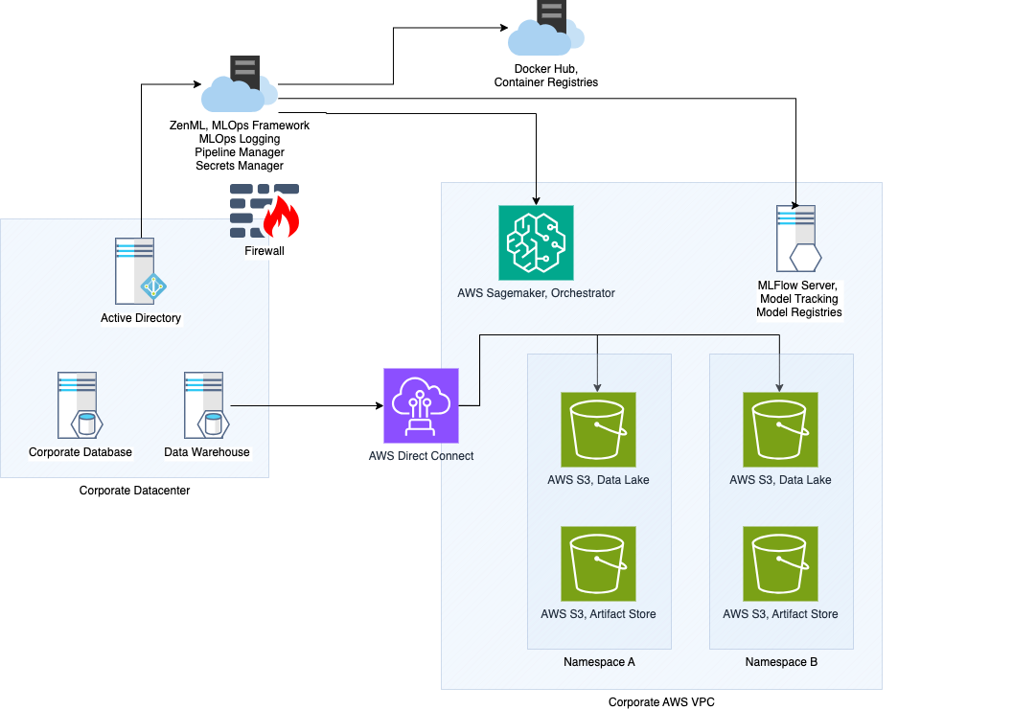

Appendix D

Regression Test Results: Home Price Prediction Model

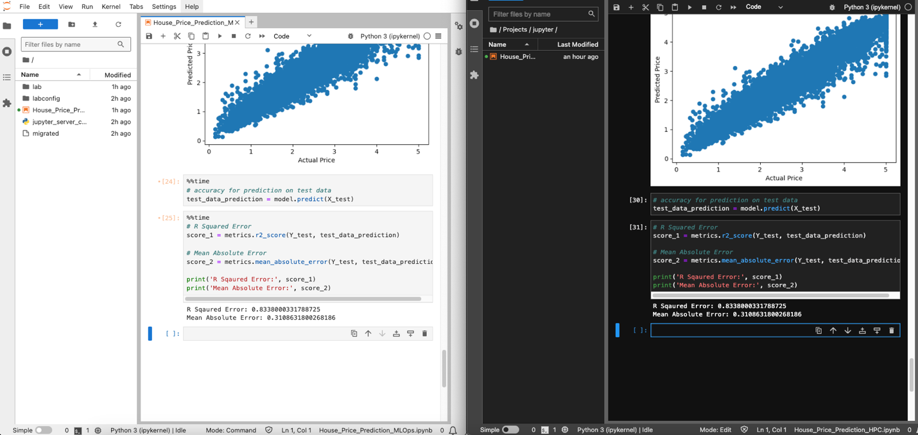
Screenshot comparing successful completion of regression test.

 | HPC Computing | MLOps Computing
 | Runtime
Start Time | 15:57:18.572616 | 23:58:04.869487
End Time | 15:57:23.618369 | 23:58:07.384870
Total (seconds) | 5.045753 | 2.515383
 | Accuracy
R Squared Error | 0.8338000331788725 | 0.8338000331788725
Mean Absolute Error | 0.3108631800268186 | 0.3108631800268186
Delta | 0 | 0
Table of paired comparison performance test.

Appendix E

Benign Script Exception Example

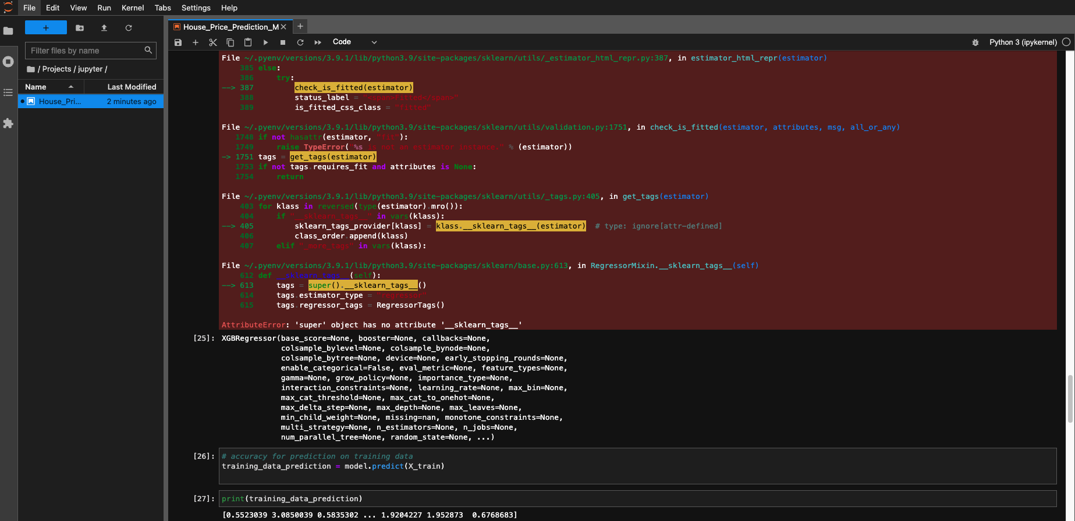
HPC configuration yielded benign exceptions due to the workstation using an older version of scikit-learn.

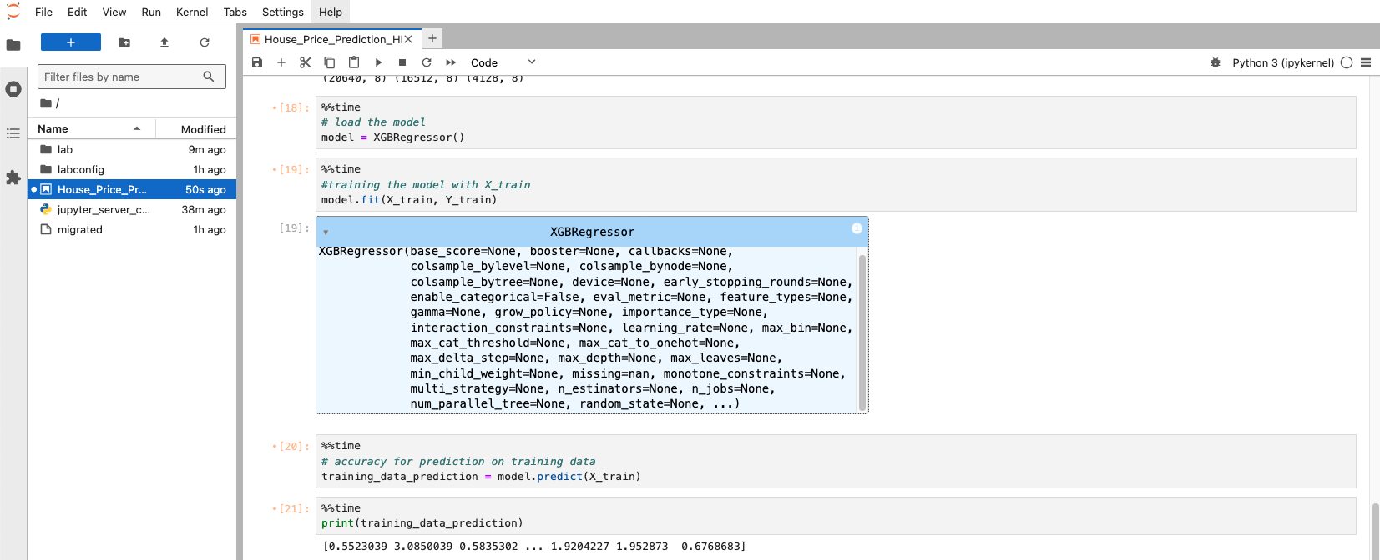
Cloud infrastructure yields no exceptions with proper dependency controls in place.

Appendix F

Code Examples

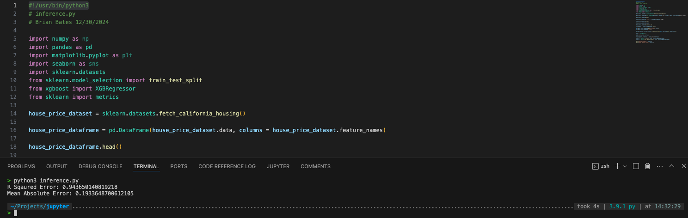
An example of fetching a dataset and running a correlation model.

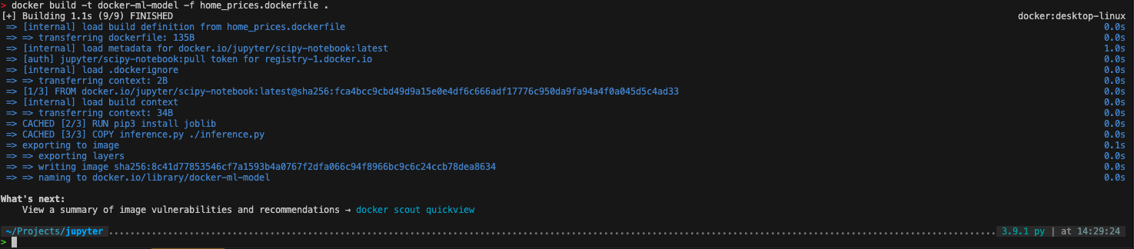
An example of creating a Dockerfile for a machine learning use case.

